AI StudyBuddy: AI-Powered Learning Assistance and Study Support Platform

Project Description:
AI StudyBuddy harnesses Generative AI to provide intelligent learning assistance, offering students a fast, secure, and personalized study preparation experience. The platform includes a Summary Generator module which produces concise revision summaries, an AI Flashcard Generator for active recall learning, an AI Quiz Generator to produce multiple-choice questions for self-assessment, and a personalized Study Plan Generator that builds custom study schedules based on exam timelines and available study hours.

Utilizing the Google Gemini 2.5 Flash API, AI StudyBuddy processes user inputs and uploaded documents (such as .txt, .md, and .pdf files) to deliver high-quality educational resources. Built with Node.js and Express.js following a modular Model-View-Controller (MVC) architecture, the platform ensures scalability, maintainability, and secure communication. With JSON Web Token (JWT) based authentication, bcrypt password hashing, and Role-Based Access Control (RBAC), AI StudyBuddy empowers students to streamline their revision and master their coursework with confidence.

Scenarios :
- Scenario 1: A student preparing for a backend development examination uploads study notes and requests an AI summary. The system instantly generates a concise, easy-to-understand breakdown highlighting core concepts, architecture details, and key definitions.

- Scenario 2: A student wanting to test active recall before an exam selects the Flashcard and Quiz generation options. The system automatically creates a set of revision flashcards and multiple-choice questions with answer options based directly on the uploaded notes.

- Scenario 3: A student with limited time before an upcoming exam inputs their available study hours per day and target exam date into the Study Plan generator. The system outputs a structured, day-by-day customized study schedule to optimize their preparation.

Technical Architecture:
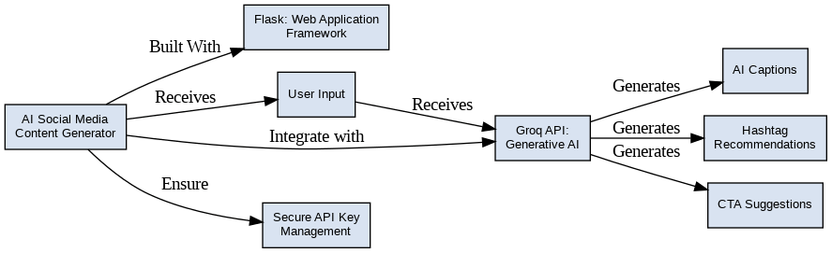
- Frontend (Client-Side): Developed using React.js / HTML / CSS to manage user input, display AI-generated learning content, and handle session navigation.
- Backend (Server-Side): Built with Node.js and Express.js, implementing REST API routing, business logic, file uploads via Multer, and JWT authentication middleware.
- AI Integration Layer: Communicates dynamically with the Google Gemini 2.5 Flash API via dedicated service modules to generate summaries, flashcards, quizzes, and personalized study plans.
- Database Layer: Utilizes MongoDB and Mongoose ODM for secure storage of user accounts, uploaded study materials, and AI-generated learning resources

Pre-requisites:
- Flask Framework Knowledge: Flask Documentation
- Groq API Familiarity: Groq API Documentation
- HTML, CSS, and JavaScript Skills: W3Schools HTML/CSS/JavaScript Tutorials
- Python Programming Proficiency: Python Documentation
- Version Control with Git: Git Documentation
- Development Environment Setup: Flask Installation Guide
- Ngrok for Public Deployment: Ngrok Documentation

Project Workflow:

• Milestone 1: Environment Setup and Configuration (Installing Node.js packages including Express, Mongoose, bcryptjs, jsonwebtoken, multer, and the Google Gen AI SDK; configuring environment variables in .env).

• Milestone 2: Database Schema Design and Authentication (Implementing Mongoose schemas for User, StudyMaterial, and security layers using bcrypt password encryption and JWT verification).

• Milestone 3: Core AI Feature Development (Building backend controllers and utility functions to parse user materials, construct prompts, and invoke the Google Gemini API).

• Milestone 4: API Testing and Integration (Verifying REST endpoints for user registration, login, material uploads, and AI content generation using Postman and Thunder Client).

• Milestone 5: Deployment and Execution (Running the server locally on Node.js with MongoDB connection management and verifying end-to-end user workflows).
Project Architecture:
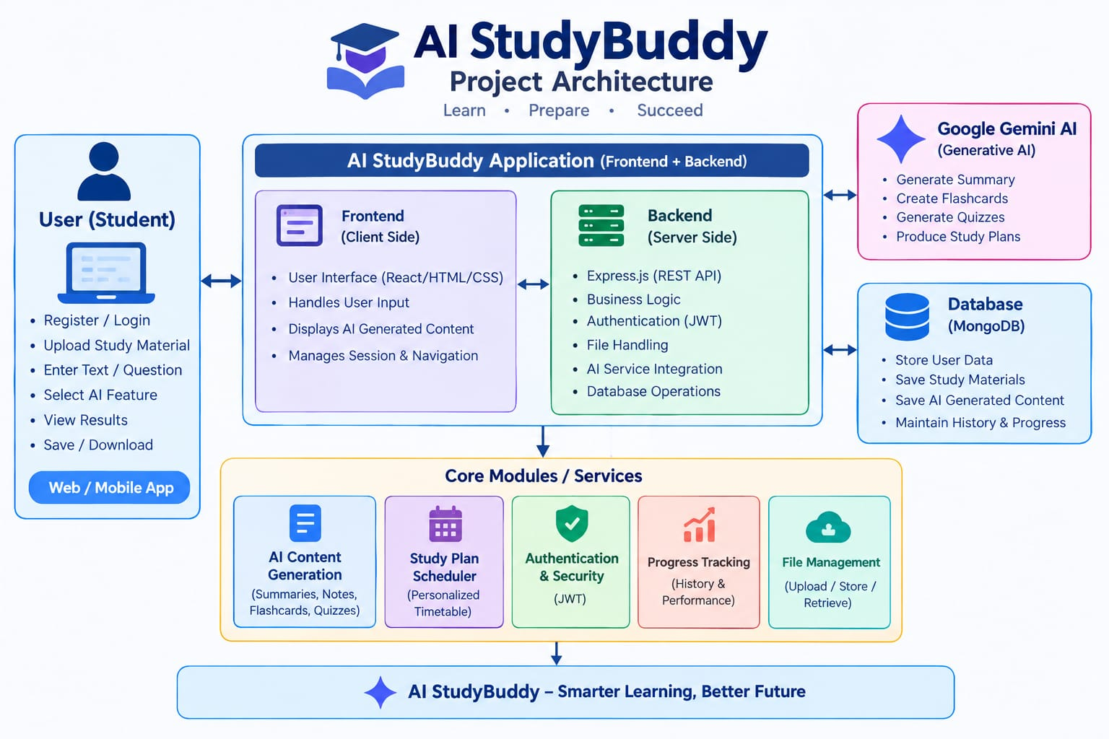

The AI StudyBuddy backend follows a modular RESTful architecture designed to provide secure, scalable, and AI-powered learning services. The system processes client requests through Express.js, validates users using JWT authentication, interacts with the MongoDB database for data storage, and communicates with the Google Gemini AI API to generate intelligent study resources.
The architecture separates authentication, business logic, AI services, and database operations into independent modules, making the application easier to maintain, extend, and debug.
Components Definition
• Client Application: The frontend (React.js) allows users to register, log in, upload study material, and access AI-powered features such as summaries, quizzes, flashcards, and study plans through REST APIs.
• Express Server: The Express.js server receives HTTP requests, handles routing, processes middleware, and sends appropriate responses to the client.
• Authentication Middleware: JWT-based middleware verifies user identity, protects private routes, and ensures that only authenticated users can access AI services and study resources.
• Route Handlers: Routes manage API endpoints related to user authentication, study materials, AI features, and administrative operations.
• AI Service Layer: A dedicated AI service communicates with the Google Gemini API to generate summaries, quizzes, flashcards, and personalized study plans based on the user's study content.
• Database Layer: MongoDB, together with Mongoose ODM, stores user information, uploaded study materials, and AI-generated learning resources securely.

Entity-Relationship (ER) Diagram Description:


The AI StudyBuddy backend manages data through interconnected MongoDB collections that store user information, study materials, and AI-generated learning resources. Each entity is linked using logical relationships to ensure efficient data management and retrieval.

1. User Entity
Stores the details of registered users and administrators.
Attributes:
- _id (Primary Key - ObjectId)
- name (String, Required)
- email (String, Required, Unique)
- password (String, Hashed)
- role (String - Student/Admin)
- createdAt

2. Study Material Entity
Stores study content uploaded by students for AI processing.
Attributes:
- _id (Primary Key)
- userId (Foreign Key → User)
- title
- subject
- content
- createdAt

3. Summary Entity
Stores AI-generated summaries.
Attributes:
- _id (Primary Key)
- userId (Foreign Key → User)
- materialId (Foreign Key → Study Material)
- summary
- createdAt

4. Flashcard Entity
Stores AI-generated flashcards.
Attributes:
- _id (Primary Key)
- userId (Foreign Key → User)
- materialId (Foreign Key → Study Material)
- question
- answer
- createdAt

5. Quiz Entity
Stores AI-generated quizzes.
Attributes:
- _id (Primary Key)
- userId (Foreign Key → User)
- materialId (Foreign Key → Study Material)
- questions
- createdAt

6. Study Plan Entity
Stores personalized study plans generated by AI.
Attributes:
- _id (Primary Key)
- userId (Foreign Key → User)
- studyPlan
- examDate
- createdAt

Key Relationships
- User → Study Material (One-to-Many): A user can upload multiple study materials.
- Study Material → Summary (One-to-One): Each uploaded material can have one AI-generated summary.
- Study Material → Flashcards (One-to-Many): One study material can generate multiple flashcards.
- Study Material → Quiz (One-to-One): One study material can generate one quiz containing multiple questions.
- User → Study Plan (One-to-Many): A user can generate multiple study plans based on different subjects or examination schedules.
- User → AI Resources (One-to-Many): All AI-generated summaries, flashcards, quizzes, and study plans are associated with the user who generated them.

Key Features
The AI StudyBuddy backend provides intelligent learning assistance through secure and scalable REST APIs. The major features of the system are as follows:
- Secure User Authentication: Implements JWT-based authentication with encrypted passwords using bcrypt for secure user access.
- Study Material Management: Allows users to upload and manage study materials that serve as input for AI-powered learning features.
- AI Summary Generation: Generates concise and easy-to-understand summaries from uploaded study content using the Google Gemini API.
- AI Flashcard Generation: Automatically creates flashcards from study materials to improve concept revision and active recall.
- AI Quiz Generation: Produces multiple-choice quizzes based on uploaded content, enabling students to test their knowledge.
- AI Study Plan Generation: Generates personalized study plans according to the user's learning goals and available study time.
- Role-Based Access Control (RBAC): Provides different access privileges for Students and Administrators to ensure secure system management.
- MongoDB Data Storage: Efficiently stores user information, uploaded materials, and AI-generated learning resources using MongoDB.

Roles and Responsibilities

Student
Students are the main users of the AI StudyBuddy application. They can register and securely log in to the system, upload their study materials, and use AI-based features such as summary generation, flashcard creation, quiz generation, and personalized study-plan creation. Students can also access, save, and manage the learning resources generated by the application

Administrator
Administrators are responsible for managing user accounts and monitoring the overall application. They can manage user access, monitor system activities, check AI service usage, and ensure that the backend services function properly. They are also responsible for maintaining system security and data management.

User Flow
The AI StudyBuddy application begins with the user registering or logging into the system. After successful JWT-based authentication, the user is redirected to the dashboard, where they can upload study materials and access AI-powered features. Based on the uploaded content, the system generates summaries, flashcards, quizzes, or personalized study plans using the Google Gemini API. All generated resources are displayed to the user and can be saved for future reference. Users can also manage their profile and view their previously generated learning resources through the dashboard.



MVC Architecture Pattern


The AI StudyBuddy backend follows the Model-View-Controller (MVC) architecture to organize the application into separate layers, making the code modular, maintainable, and scalable.

Model Layer (Data Layer)
The Model layer defines the MongoDB collections using Mongoose schemas. It is responsible for managing user information, uploaded study materials, and AI-generated learning resources while ensuring data validation and database interactions.

View Layer (API Response Layer)
Since AI StudyBuddy is a backend REST API, there is no traditional user interface in the View layer. Instead, the API returns structured JSON responses to the React frontend, allowing users to interact with the application through REST endpoints.

Controller Layer (Business Logic)
The Controller layer processes incoming API requests, validates user input, performs authentication and authorization, communicates with the database models, invokes the Google Gemini AI service when required, and returns the appropriate response to the client.

MVC Benefits
The MVC architecture separates data management, business logic, and client communication into independent components. This improves code readability, simplifies debugging and testing, and allows new features to be integrated without affecting existing modules.

Epic 2: Project Setup and Configuration

Creating the Project Folder
- Create a new folder named AI StudyBuddy .
- Open the project folder in Visual Studio Code.
- Initialize the project using Node.js and install the required dependencies.

Project Initialization
Open the project folder in the VS Code terminal and execute:
npm init -y
Install the required dependencies:
npm install express mongoose bcryptjs jsonwebtoken cors dotenv multer @google/genai
Install Nodemon for development:
npm install --save-dev nodemon

Create the Following Files
- index.js
- .env
- package.json
- .gitignore

Create the Following Folder Structure


Environment Configuration
Create a .env file in the project root and configure the required environment variables.
PORT=5000
MONGO_URI=your_mongodb_connection_string
JWT_SECRET=your_jwt_secret
GEMINI_API_KEY=your_gemini_api_key

Epic 3: Backend Development
Backend development is responsible for managing the server-side operations of the AI Study Buddy application. It handles user authentication, study material management, AI-based content generation, database communication, and administrative functions.

The backend is developed using Node.js, Express.js, and MongoDB. It uses a modular structure in which routes, controllers, middleware, models, and utility functions are organized separately. This makes the application easier to maintain, update, and expand.

The backend also provides secure REST APIs that connect the frontend with the database and AI services. Through these APIs, users can upload study materials, generate summaries, flashcards, quizzes, and personalized study plans while securely storing and managing their learning resources.

Backend Structure


Core System Script Implementations

1. Application Entry Point (index.js)
The index.js file serves as the main entry point of the application. It initializes the Express server, loads environment variables, configures middleware, establishes the MongoDB connection, registers API routes, and starts the server after a successful database connection.
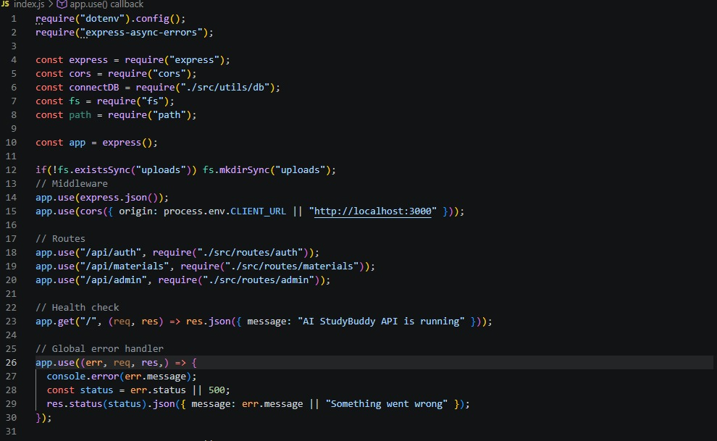

2. Database Connection (src/utils/db.js)
This module establishes a connection between the application and MongoDB using Mongoose. It ensures that the backend communicates with the database before processing any client requests.
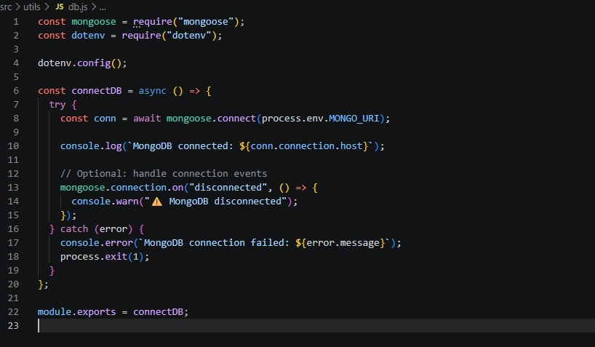

3. Authentication Middleware (src/middleware/auth.js)
The authentication middleware verifies JWT access tokens for protected routes. It authenticates users before granting access to secured APIs and includes role-based authorization to restrict administrative operations.
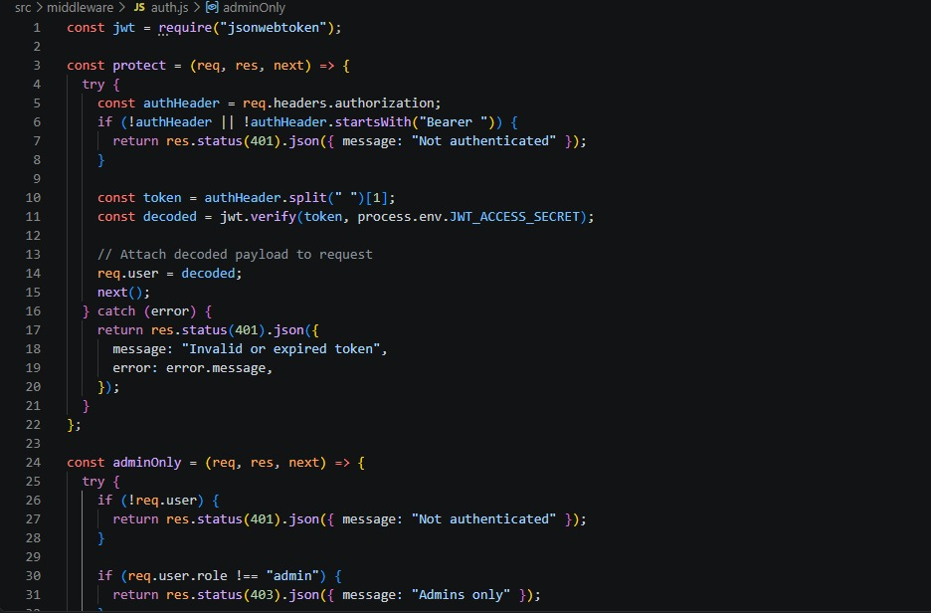

4. AI Integration (src/utils/gemini.js)

This utility integrates the backend with the Google Gemini 2.5 Flash API. It sends prompts to the AI model and returns generated responses for summaries, flashcards, quizzes, and study plans.
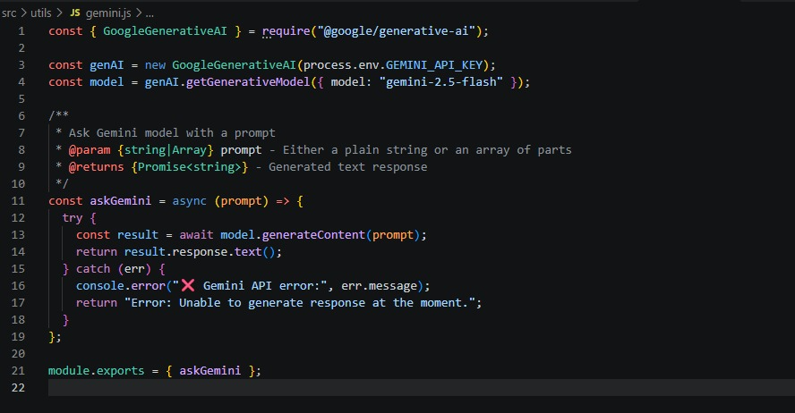

5. File Upload Middleware (src/middleware/upload.js)
The upload middleware handles study material uploads and validates incoming files before they are processed by the backend.

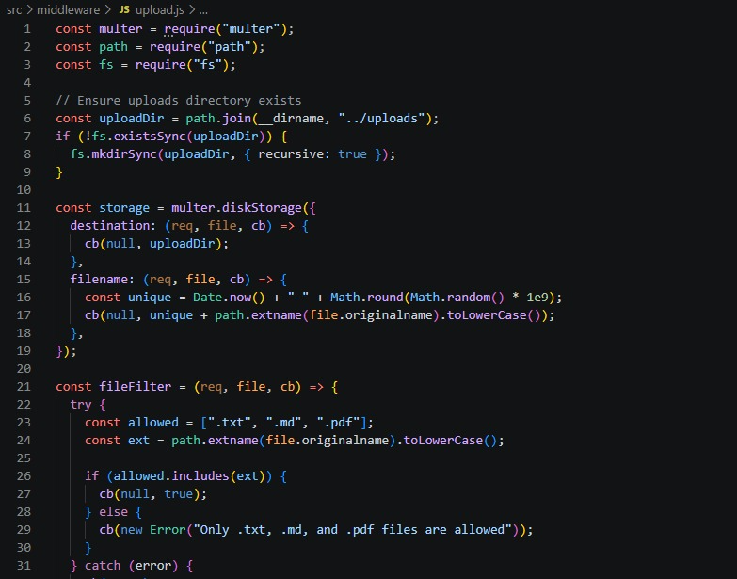

Epic 4: Database Configuration
The AI StudyBuddy backend uses MongoDB as its primary NoSQL database and Mongoose ODM for data modeling and schema validation. MongoDB stores user information, uploaded study materials, and AI-generated learning resources in a structured manner. Mongoose simplifies database operations by providing schemas, validation rules, and efficient query handling.

Configure MongoDB
Install Mongoose using the following command:
npm install mongoose

Create Database Connection
Before performing any database operations, establish a connection between the backend and MongoDB using Mongoose. The connection module is initialized during server startup to ensure reliable communication with the database.

Mongoose Schema Definitions

1. User Schema (models/User.js)
The User schema stores authentication and profile information for registered users. It includes fields such as name, email, password, and role. Passwords are securely encrypted before bring

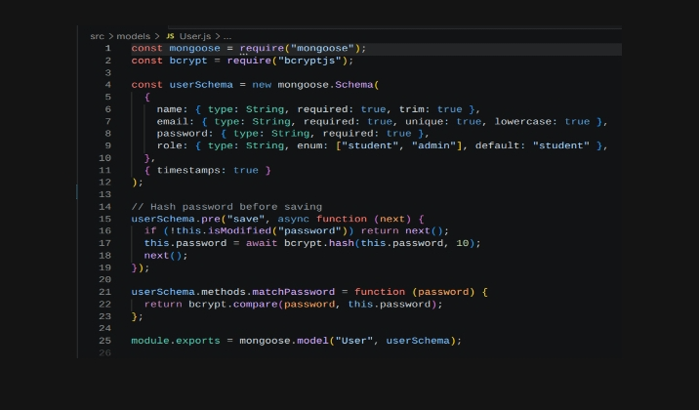

2. Study Material Schema (models/Material.js)
The Study Material schema stores the learning content uploaded by users. This content acts as the input for AI-powered features such as summaries, quizzes, flashcards, and study plans.


Database Collections
The AI StudyBuddy database consists of the following collections:
- Users – Stores user account and authentication details.
- Study Materials – Stores uploaded learning materials.

API Route Interface Endpoints
The backend exposes RESTful APIs to interact with the database and AI services.

1. Authentication APIs
Handles user registration, login, JWT authentication, and protected route access.

2. Study Material APIs
Allows users to upload, retrieve, update, and manage study materials.
3. AI Feature APIs
Provides endpoints for:
- AI Summary Generation
- AI Flashcard Generation
- AI Quiz Generation
- AI Study Plan Generation

4. Administrative APIs
Provides administrator-only endpoints for managing users and monitoring system activities.

Epic 5: Project Execution
The AI StudyBuddy backend can be executed locally using Node.js. Before running the application, ensure that MongoDB is running and the required environment variables are configured correctly. The backend exposes REST APIs that can be tested using Postman or Thunder Client.

Running the Backend Server
Install all required dependencies:
npm install
Start the development server:
npm start
After successful execution, the server connects to MongoDB and starts listening for incoming API requests.
API Testing
The backend APIs can be tested using Postman.

1. User Registration
Registers a new user by accepting the required details and securely storing the encrypted password in the MongoDB database.
Endpoint:
POST /api/auth/register

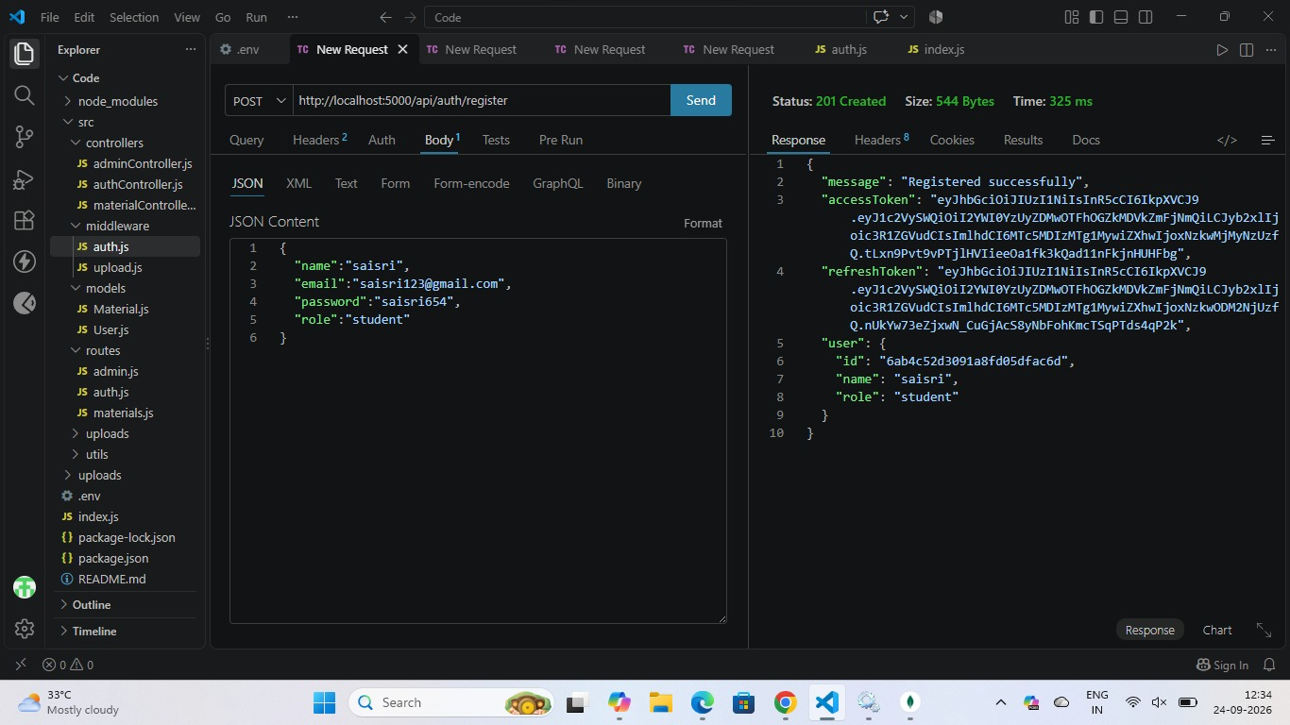

2. User Login
Authenticates the registered user and generates a JWT access token for accessing protected APIs.
Endpoint:
POST /api/auth/login
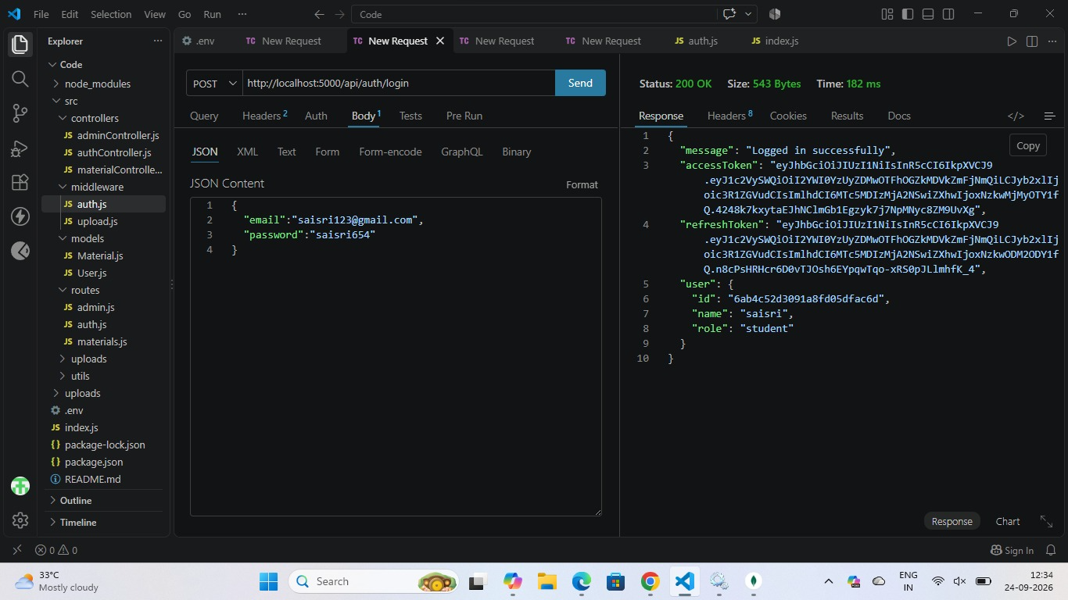

3. Upload Study Material
Allows authenticated users to upload study material that will be used as input for AI-powered content generation.
Endpoint:
POST /api/material/upload


4. Generate AI Summary
Sends the uploaded study material to the Google Gemini API and generates a concise summary.
Endpoint:
POST /api/materials/:id/summarize

5. Generate AI Flashcards
Creates AI-generated flashcards from the uploaded study material for effective revision.
Endpoint:
POST /api/ai/flashcards



6. Generate AI Quiz
Generates multiple-choice questions from the uploaded study material to help users assess their understanding.
Endpoint:
POST /api/ai/quiz



7. Generate AI Study Plan
Creates a personalized study schedule based on the user's learning goals and available study time.
Endpoint:
POST /api/ai/study-plan


DEMO VIDEO LINK: https://drive.google.com/file/d/1kz1TlfNe1vvIOZVTNodk8zolDrpqTcPE/view?usp=drivesdk

Code Drive Link : https://1drv.ms/f/c/b0173052b5dd3df9/IgCO25HZtFUWTq96_K9deGckAePYaHa5mffWjILz2X400m0?e=JJf0O7

Conclusion:
The AI StudyBuddy project successfully combines artificial intelligence with a secure backend system to make the learning process more convenient and efficient for students.
Key takeaways and outcomes of the project include:
- Enhanced Productivity: Automated generation of summaries, flashcards, quizzes, and study plans reduces the time spent on manual preparation, allowing students to focus on understanding important concepts.
- Robust Security & Architecture: The integration of JWT-based authentication, encrypted passwords via bcrypt, MongoDB, and the Google Gemini AI API ensures secure and efficient management of educational resources.
- Modular Scalability: The modular Model-View-Controller (MVC) design makes it easy to introduce new AI-based learning features in the future without major changes to the existing codebase.
- Overall Impact: AI StudyBuddy provides an intelligent, flexible educational platform that helps students improve study productivity, organize revision, and support personalized preparation for examinations and assessments.

